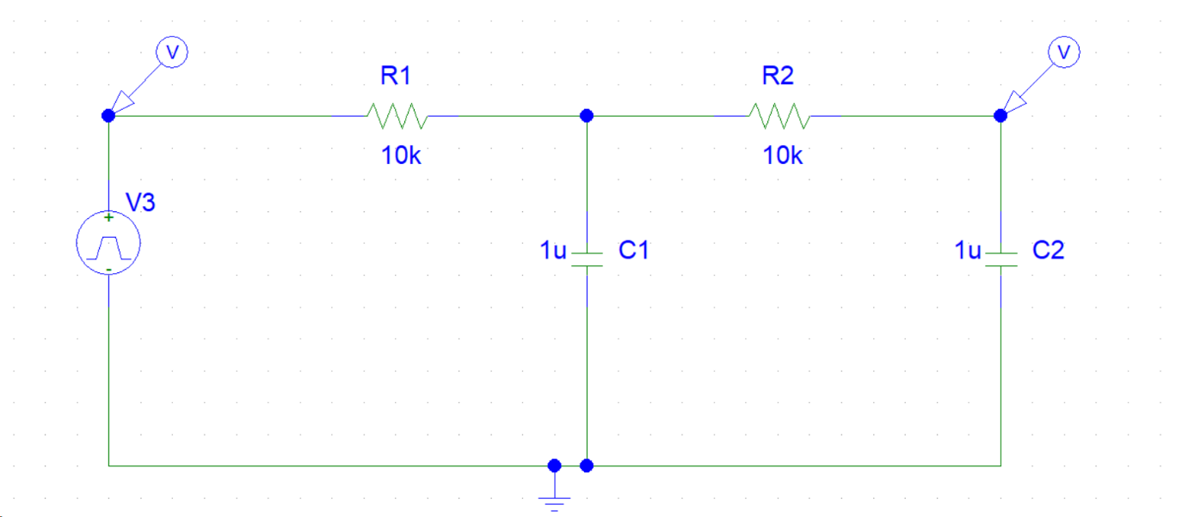Schematic Diagram of the plant (Analogous to a mechanical system)

Output of the plant without PID

Schematic of PID Controller

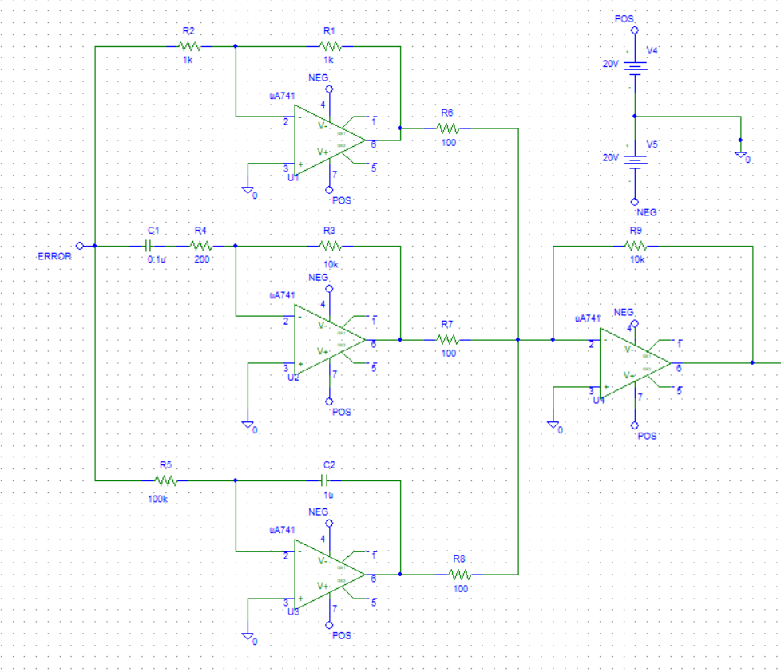

BIAS VOLTAGE

INVERTING ADDER

INTEGRAL

DIFFERENTIATIAL

PROPORTIONAL

Schematic of PID with tuning

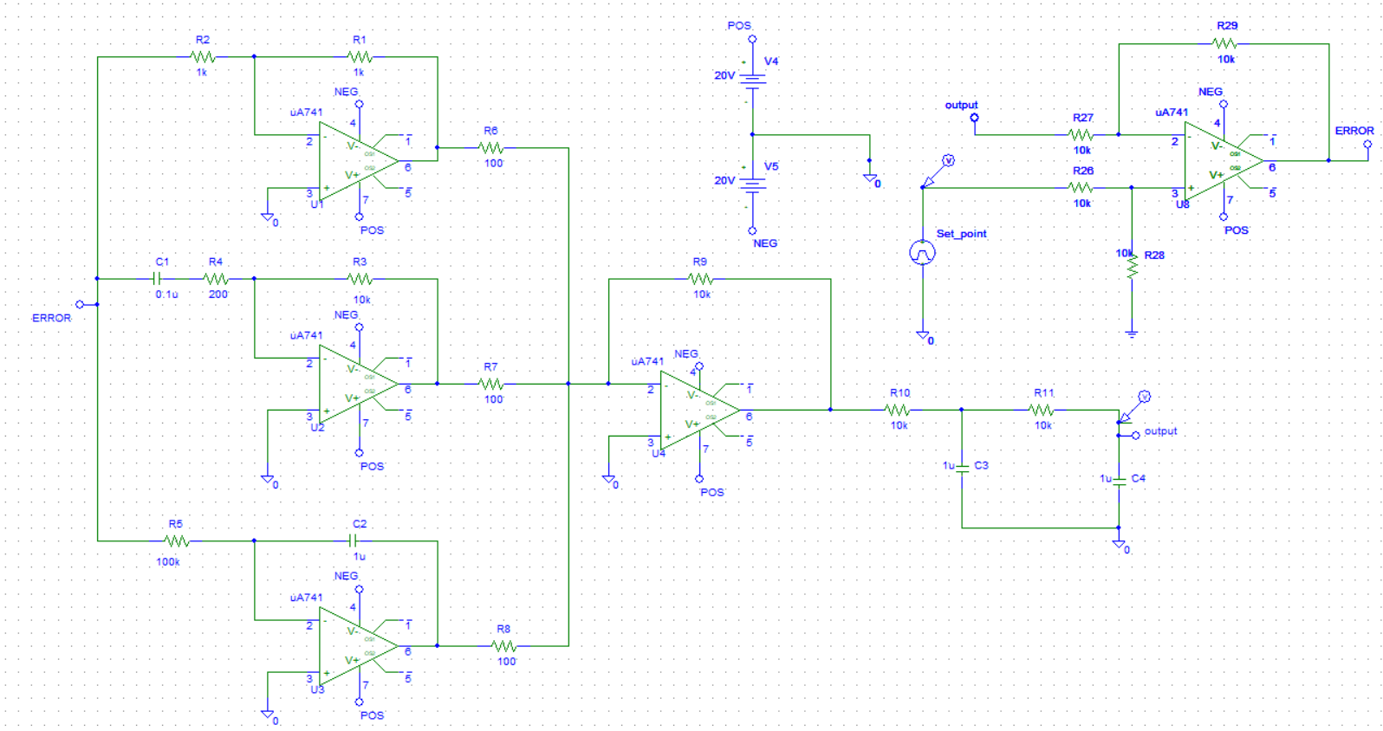

Output after tuning with PID controller



Effects of Proportional, Integral and Differential Block individually

Step Response without PID

Step Response with varying Kp (Holding KD and KI constant)

Kp=10

Kp=1

If we increase Kp from 1 to 10, varying the feedback resistor of the op amp of the proportional block of the PID controller, we can see

1. The steady state error decreases
2. The rise time decreases
3. The overshoot increases
4. The setting time increases

Step Response with varying KI (Holding Kp and KD constant)



KI=10

KI=20

If we increase KI from 10 to 20, by varying the resistance R5 and holding Kd and Kp constant, we can observe

1. The rise time decreases
2. The setting time increases
3. The steady state error tends to 0
4. The overshoot increases

Step Response with varying KD (Holding Kp and KI constant)

If we increase the value of Kd, by varying the resistance R3 and holding Ki and kp constant, we can observe

1. The rise time increases
2. The setting decreases
3. The overshoot decreases (no overshoots)
4. Steady state error remains unchanged

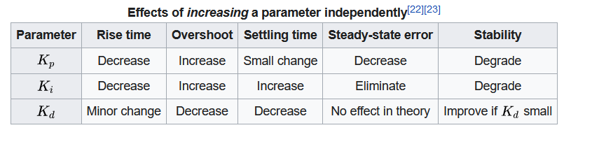

Manual Tuning

Step:1 varying Kp (Making Kd and Ki zero)



Step:2 varying Ki (Holding Kp constant and Kd = 0)



Step:3 varying Kd (Holding Kp and Ki constant)